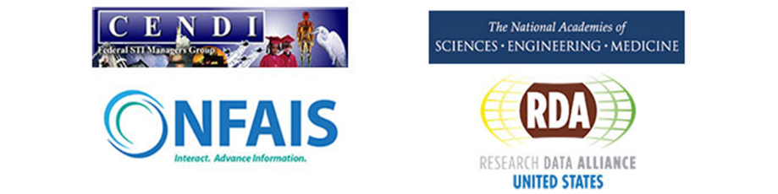
“Managing Digital Research Objects in an Expanding Science Ecosystem”
Wednesday, November 15th, 2017
9:00 am - 5:00 pm EST
Lister Hill National Center for Biomedical Communications
U.S. National Library of Medicine/NIH
8600 Rockville Pike, Bethesda, MD 20894
“We are at a tipping point in the development of a common conceptual framework and set of tools and components which will revolutionize the management of scientific data.”¹
Keynote Speaker Presenting the Global Challenge
Peter Wittenberg, (bio)
¹Co-Editor of Recommendations for Implementing a Virtual Layer for Management of the Complete Life Cycle of Scientific Data

Sessions on
- Developing Frameworks that Address the Challenge
- Identifiers as an integral Part of the Scholarly Record
  - Creating and Maintaining Standards for Object Identifiers, Persistent Identifiers for Data Sets, Industry Incorporation of Identifiers
- Using multiple, interlinked, and evolving research artifacts to advance research
- Connecting Users with Digital Research Objects
  - Scientific Use Case Analysis, Metadata Harmonization, Linked Open Data Approach, Sustainable Environment/Actionable Data
- Filling the Gaps and Moving the Agenda Forward
Register Now!
(Use FY17 or FY18 funding)
https://goo.gl/eyc9B2
Co-sponsored by CENDI, National Federation of Advanced Information Services (NFAIS), Research Data Alliance/US (RDA/US), and the National Academies Board on Research Data and Information. Hosted by The National Library of Medicine/NIH
Contact Information:
Heather M. Parrish  CENDI  E-mail: hparrish@iiaweb.com  Phone: 865-298-1245 | Nancy Blair-DeLeon NFAIS  E-mail: nblairdeleon@nfais.org  Phone: 443-221-2980, ext. 102 | Lynn Yarmey RDA/US  E-mail: yarmel@rpi.edu  Phone: 858-722-0127 | Ester Sztein  NAS  E-mail: esztein@nas.edu Phone: 202-334-3049

